Upload the synopsis for your mini project to be implemented.

The synopsis shall include:

1. Problem statement

**Cricket score card** - A database system to keep track of cricket tournament statistics.

1. Objectives

* Maintain record of team score
* Maintain record of individual player performance
* Maintain record of matches in tournaments( win/loss )
* Maintain ranking of teams in tournament
* Creation, Maintenance, modifying of details about the teams and players

1. Functional requirements

* Python
* Tkinter module for gui
* mysql
* pymysql module

1. ER diagram

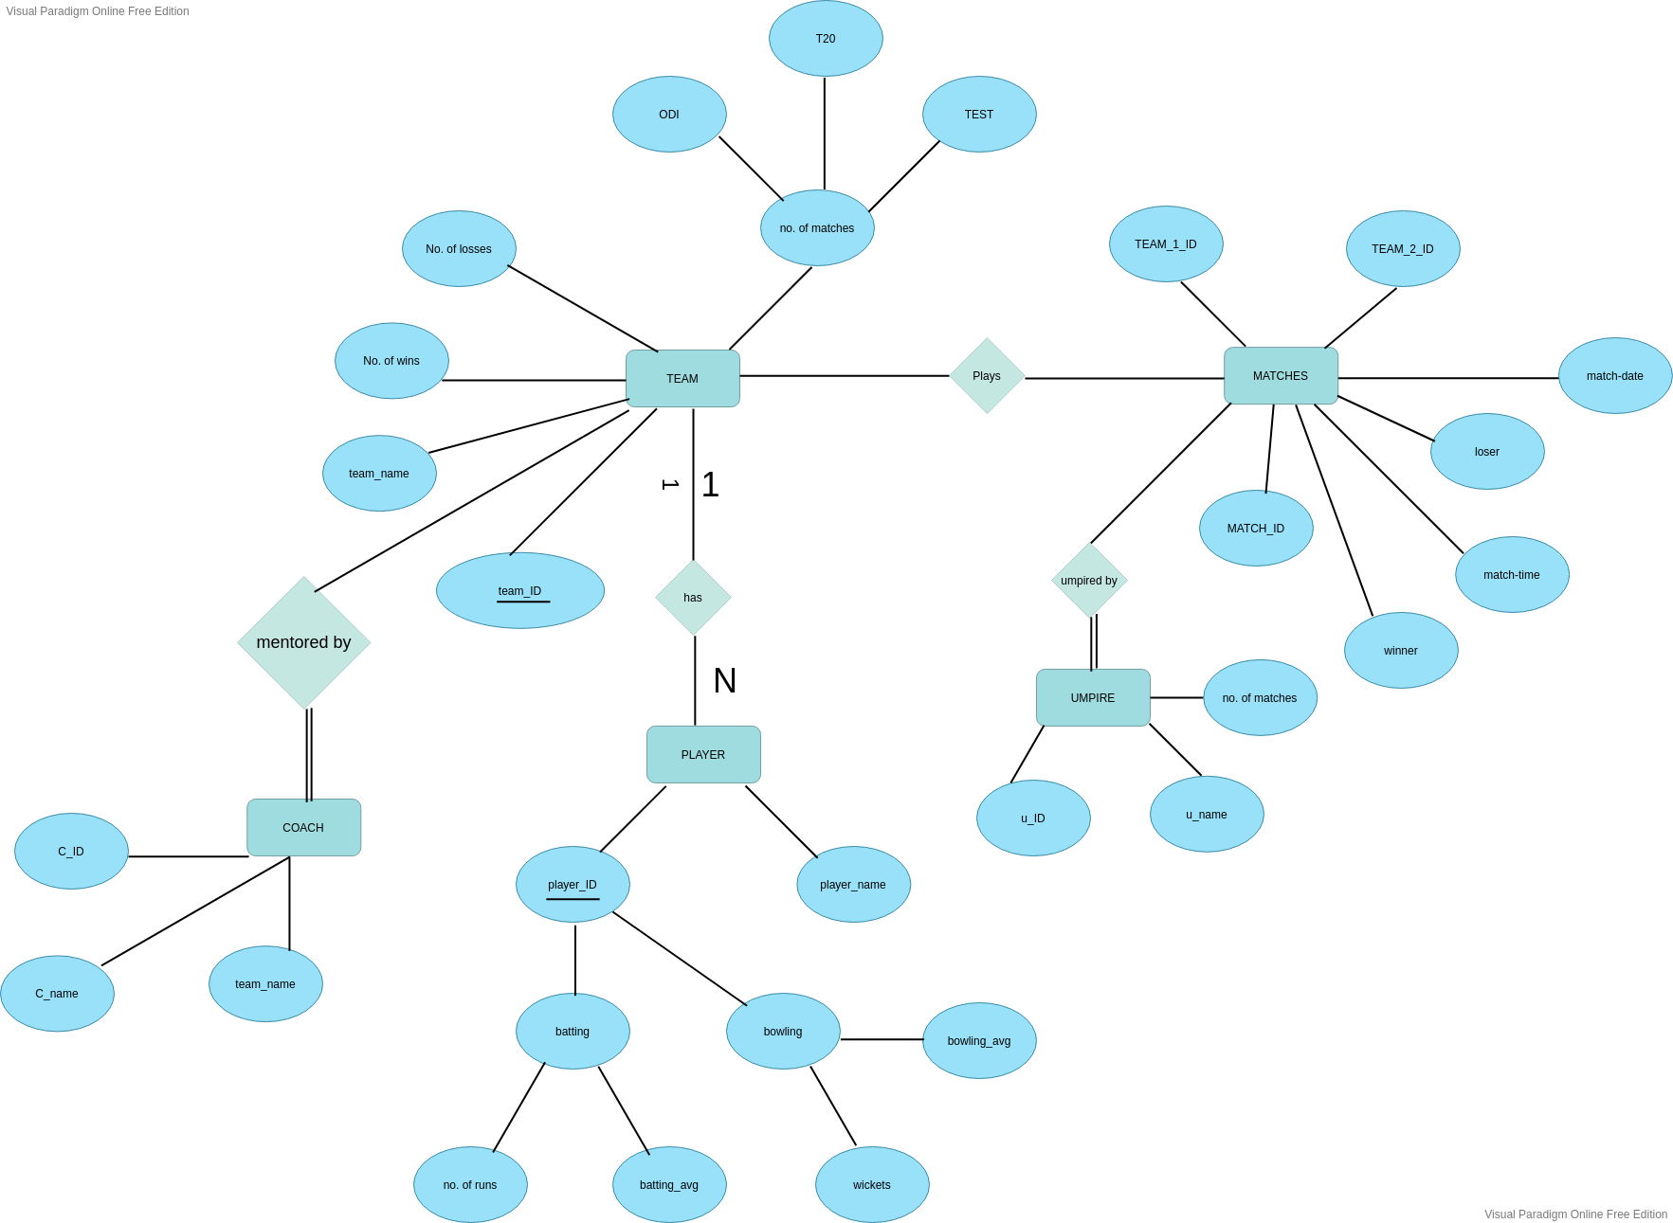

1. Relational schemas obtained from ER.

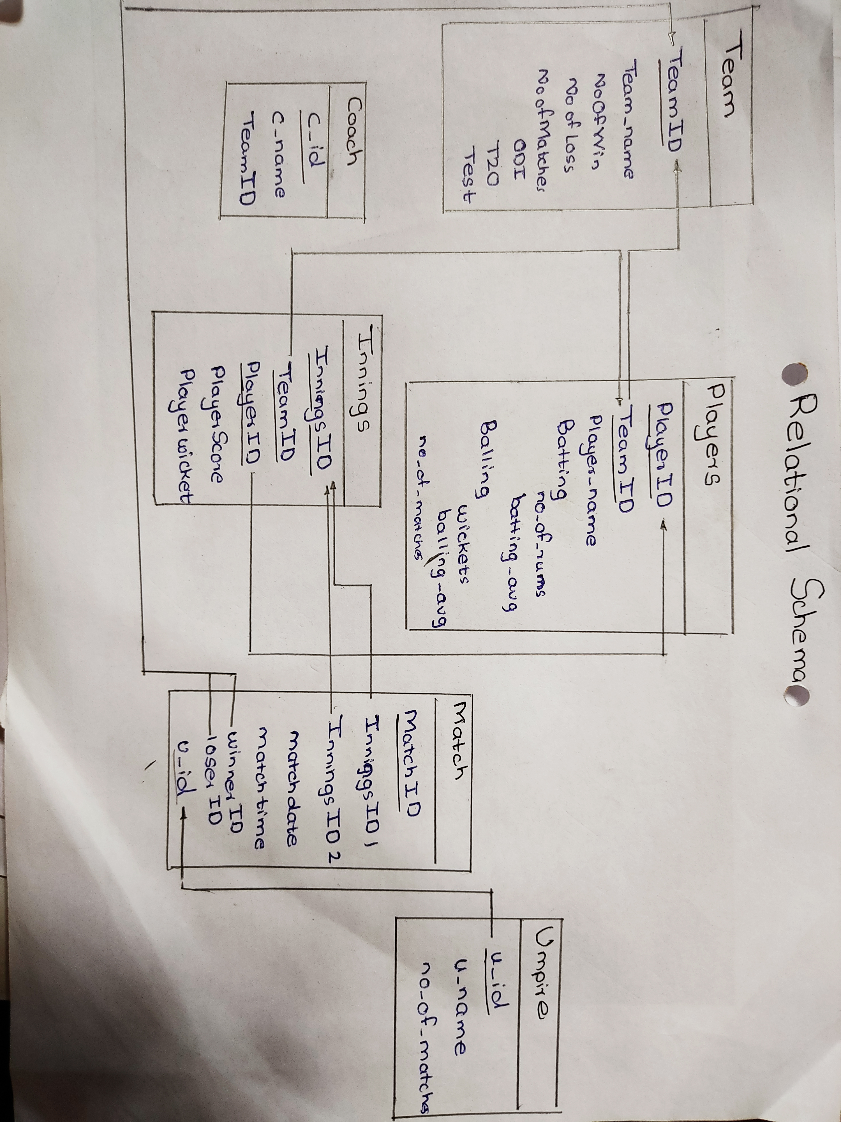

1. Set of Functional dependencies that must hold on each table.

team(TeamID) → team(Team_name,NoOfWin,NoOfLoss,c_id)

coach(c_id) → coach(c_id,c_name,TeamID)

player(PlayerID,TeamID) → player(Player_name, Batting, Bowling,No_of_matches)

Innings(InningsID) → Innings(TeamID, PlayerID, PlayerScore,PlayerWicket)

1. Each table has to be normalized upto 3NF.

Submission will be in the form of doc file. ER diagram can uploaded separately (image file) as most of the student draw it by hand. Maximum two files .